**Design Document for:**

# Noo Noo’s Adventure

All work Copyright ©2024 by AAA(A)

Written by Zack Cornfield, Jacob Mondi, Milad Rakhshbahar

Version # 1.0

**Saturday, April 13, 2024**

GitHub Repo: <https://github.com/stiletj/AAAAEngine>

**Table of Contents**

Noo Noo’s Adventure 1

Game Overview 4

Common Questions 5

What is the game? 5

What is the genre? 5

Why create this game? 5

Where does the game take place? 5

What do I control? 5

How many characters do I control? 5

What is the main focus? 5

What’s different? 5

Background/Inspiration 5

Teletubbies 6

Devil Daggers 6

Feature Set 6

General Features 7

Game Play 7

Key Features 7

Game World 7

Overview 8

Key Locations 8

Visual Style 8

Character Design 8

Interactive Objects 8

Day-Night Cycle 8

Time 8

Rendering System 8

Overview 8

2D/3D Rendering 8

Camera 9

Overview 9

Camera Detail #1 9

Game Engine 9

Overview 9

Game Engine Features 9

Lighting Models 10

Overview 10

Lighting 10

World Layout 11

Overview 11

World Layout Detail #1 11

World Layout Detail #2 11

Game Characters 12

Noo-Noo 12

NPC Teletubbies 12

User Interface 13

Overview 13

Main Menu 13

Escape Menu 13

Weapons 14

Overview 14

Details 14

Single-Player Game 15

Overview 15

Single Player Game Detail #1 15

Story 15

Hours of Gameplay 15

Victory Conditions 15

Technical Specifications 16

Platform Compatibility 16

Engine 16

Input Devices 16

Credits and References 17

Windmill 3D Model 17

Tubbytronic Superdome 3D Model 17

Teletubbies 17

Teletubbies Tubbytronic Superdome 17

Low Poly Trees Free 17

Low Poly Shrub – Small Texture 18

Stylized lowpoly rock 18

# Game Overview

## Common Questions

### What is the game?

Noo-Noo's Adventure is a survival game set in the world of Teletubbyland, where players control Noo-Noo and must fend off oncoming Teletubbies using rocks and blasts of air.

### What is the genre?

Noo-Noo’s Adventure can be best described as an Adventure/Survival game. Set in the world of "Teletubbies," the game offers players a unique and immersive experience unlike any other.

### Why create this game?

We created Noo-Noo's Adventure to offer players a unique and challenging gameplay experience inspired by the "Teletubbies" television show.

### Where does the game take place?

The game is set in the world of Teletubbyland, featuring landmarks and characters from the television show with a twist.

### What do I control?

Player’s control Noo-Noo, the trusty vacuum cleaner, as they navigate through Teletubbyland and fend off oncoming Teletubbies.

### How many characters do I control?

Players control a single character, Noo-Noo, throughout the game.

### What is the main focus?

The main focus of Noo-Noo's Adventure is survival, as players must evade capture by oncoming Teletubbies and prolong their survival for as long as possible.

### What’s different?

Noo-Noo's Adventure offers a unique and challenging survival experience set in the world of Teletubbyland, where players must use their wits and reflexes to outsmart their opponents and achieve high scores.

## Background/Inspiration

### Teletubbies

Teletubbies is a British children's television series created by Anne Wood and Andrew Davenport for the BBC. The programme focuses on four differently coloured characters known as the Teletubbies, named after the television screens on their bellies.

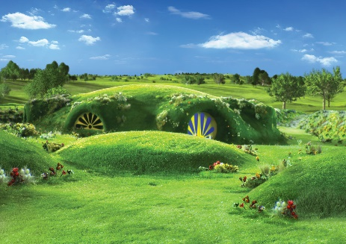 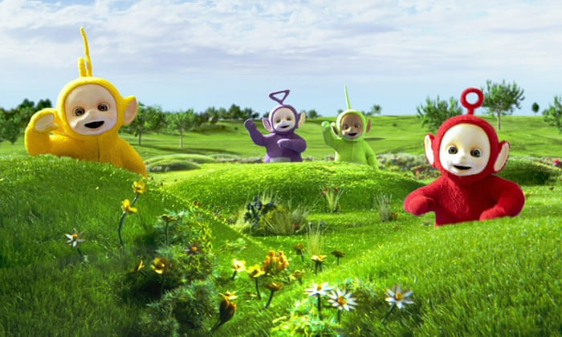

### Devil Daggers

Devil daggers is a survival game where the player has to defeat an onslaught of devils and as the game goes on the difficulty increases with the gameplay speed increasing and more devils appearing. The player cannot jump but can move and shoot.

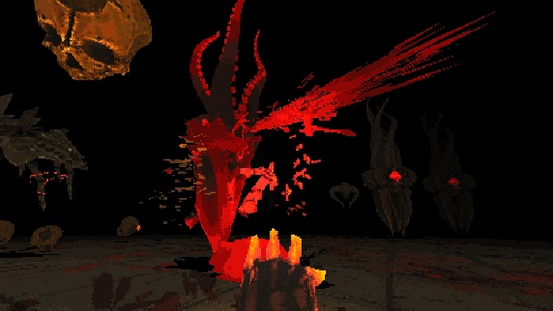

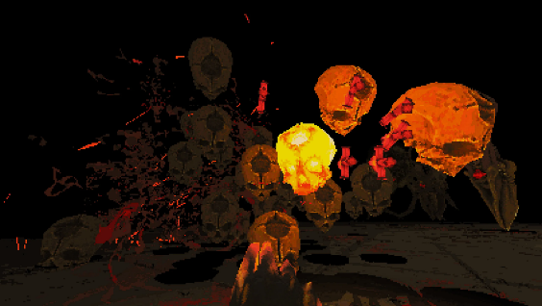

# Feature Set

## General Features

* Intense single-player survival experience set in Teletubbyland.
* Dynamic and challenging gameplay mechanics that test players' reflexes and strategy.
* High scores and leaderboard system to track player achievements and competitiveness.

## Game Play

* Player’s control Noo-Noo as they navigate through Teletubbyland, using suction abilities to collect and launch rocks at oncoming Teletubbies.
* The game features increasingly difficult waves of enemies, requiring players to adapt their strategies and reactions to survive for as long as possible.

## Key Features

* A 3D movement system that includes:
  + Walking: Basic, in most modern games
* Unique Gameplay Mechanics:
  + Aerial Dodge: Dodging left and right in the air to avoid being caught by the NPCs.
  + Vacuum Suction: Utilize Noo-Noo's powerful suction capabilities to collect rocks scattered across the landscape, essential for interacting with the environment and defending against the wandering Teletubbies.
  + Shooting Mechanism: Launch rocks collected by the vacuum at the NPCs to fend them off and maintain control of the surroundings.
  + Air Blast Mechanism: Launch a gust of air out of the vacuum pushing both you and the NPCs away from you.
  + Cooldown Mechanism: Certain abilities will have cooldowns to prevent spamming and enhance the difficulty.
* High Score System (Time alive)
* Continues game (no end objective)
* Skybox
* CLOD algorithm (terrain)
* Menu System
  + Start
  + Save
  + Restore
* Multiple NPC types
  + Type one will stop moving when you look at it.
  + Type two will just be the standard type of enemy that just chases you and dies to stones, multiple of these will spawn at each stage of the game.
  + Type three will require you to throw 2 rocks at it to kill it.
  + Type four will move faster than others.
  + Type five only dies to air blast and not stone (stones will pass through it).
  + Type six is normal type but cannot go into water.

# Game World

## Overview

Noo-Noo's Adventure is set in the world of Teletubbyland, where players must use their skills and wits to survive against waves of oncoming Teletubbies.

## Key Locations

* Rolling Hills: The undulating terrain of Teletubbyland provides natural cover and obstacles for players to navigate and evade their pursuers.
* Tubbytronic Superdome: A central landmark in Teletubbyland where players spawn, also serving as a refuge and strategic vantage point for the player.

## Visual Style

The art style of Noo-Noo's Adventure is a twist of the iconic and known environmental design of Teletubbies, giving it darker elements to suggest a darker tone, which will better align with the vision of the game, being more unsettling and scarier.

## Character Design

The characters in Noo-Noo's Adventure are brought to life with expressive animations and stylized designs that stay true to their counterparts from the Teletubbies show.

## Interactive Objects

The ground is scattered with rocks that the player can pick up and propel at surrounding NPC’s.

## Day-Night Cycle

Teletubbyland follows a dynamic day-night cycle, with transitions between day and night affecting the appearance and behaviour of the environment. Nighttime brings starry skies and glowing landscapes, while daytime reveals vibrant colours and bustling activity.

## Time

In our game time will follow a continuous and looping day-night cycle where 5 minutes is equivalent to 24 hours.

## Rendering System

### Overview

The rendering system is responsible for displaying graphics to the screen. This include rendering objects, textures, lighting, shaders, and any other element that would be required to render an image to the screen.

### 2D/3D Rendering

The game is rendered using OpenGL and GLFW. OpenGL allows for object data to be loaded into buffers that can be used by the GPU to render objects at runtime. Texture mapping, shaders, and lighting are also rendered through OpenGL.

## Camera

### Overview

The camera is responsible for giving the player an avenue to see the game world. The camera contains a view frustum, which states what objects the player is currently seeing. This frustum can be simplified to a close clipping plane and a far clipping plane, which defines the range (relative to the camera) of objects that can currently be seen by the camera, and thus what is currently being rendered.

### Camera Detail #1

We are implementing a first-person camera into the game. The movement of the camera is done by moving the mouse.

The main camera is connected to the player. It will move around following the player in a first-person perspective. Moving the mouse along the x-axis rotates the camera to look left and right. Moving the mouse along the y-axis rotates the camera up and down, with the camera clamped to not rotate over 90 degrees and -90 degrees, stopping the rotation when looking straight up, or straight down.

## Game Engine

### Overview

Our game run on the custom AAAA engine. This is an engine built with C++ and interacted with through LUA scripts. The 3D rendering is achieved through GFLW The AAAA engine is an entity component system (ECS). Game Objects are represented as entities, these objects can then be assigned components (attributes). For example, a Player entity could have a physics component and a transform component.

### Game Engine Features

• Physics with ReactPhysics3D

• Collision Detection with ReactPhysics3D

• GUI with ImGUI

• Mesh Loading and Rendering

• Scripting with LUA

• ECS system with ENTT

• Custom Terrains (With Continuous Level of Detail)

• Camera control

• Texture Management

• Skyboxes

• Input Handler (Powered by OpenGL)

## Lighting Models

### Overview

Our game uses a single directional light that hits everything in our scene.

Lighting Model Detail #1

# World Layout

## Overview

The world layout in Noo-Noo's Adventure is designed to immerse players in the landscapes of Teletubbyland. From rolling hills to various landmarks, the environment offers both challenges and opportunities for survival as players navigate the terrain and fend off oncoming adversaries.

## World Layout Detail #1

* Terrain Diversity: Teletubbyland features diverse terrain, including rolling hills, lush meadows, and winding paths, providing players with varied gameplay experiences and strategic options. Each area presents unique challenges and obstacles, requiring players to adapt their tactics and navigation skills accordingly.
* Strategic Points of Interest: Throughout the world, players will encounter strategic points of interest such as elevated platforms, natural cover. These points offer players opportunities to gain tactical advantages, evade pursuit, and outmaneuver adversaries.

## World Layout Detail #2

* + Exploration Opportunities: Beyond the immediate threats posed by oncoming Teletubbies, the world layout encourages exploration and discovery. This may include searching for better vantage points to survey the surrounding landscape and plan strategic maneuvers. Additionally, exploration may reveal environmental hazards and obstacles that players must navigate carefully to avoid detection or capture.

The world layout in Noo-Noo's Adventure is crafted to engage players in an immersive and dynamic experience, where survival hinges on quick thinking and strategic planning.

# Game Characters

## Noo-Noo

* The protagonist and player character of Noo-Noo's Adventure.
* Noo-Noo is a vacuum cleaner from the show which you will play as.
* Armed with powerful suction capabilities, Noo-Noo's primary objective is to collect rocks scattered across the colourful landscapes and use them to fend off the mischievous NPC Teletubbies.

## NPC Teletubbies

* The NPC Teletubbies serve as the primary antagonists and obstacles throughout Noo-Noo's Adventure.
* As players progress through the game, they encounter different-colored Teletubbies representing varying levels of difficulty and challenges.
* Each Teletubby exhibits unique behaviors and characteristics, posing different threats and requiring strategic approaches to overcome.
* From the calm and playful demeanor of the easier stages to the more challenging and mischievous behavior of the higher difficulty stages, players will need to adapt their tactics and reactions accordingly.
* The progression of NPC Teletubbies adds depth and complexity to the gameplay experience, ensuring that players remain engaged and challenged as they explore the world of Teletubbyland alongside Noo-Noo.

# User Interface

## Overview

The user interface (UI) in Noo-Noo's Adventure is designed to provide players with essential information and controls to navigate the game world and interact with various elements seamlessly. From the main menu to in-game overlays, the UI enhances the player experience and facilitates smooth gameplay.

## Main Menu

The Main Menu serves as the gateway to the game, offering players essential options to begin their adventure or exit the game. It features clear and intuitive navigation options, ensuring players can easily access the desired functionalities. The following options are available:

* Start Game: Allows players to start the game.
* Exit: Provides players with the option to exit the game and return to their desktop or operating system.

## Escape Menu

The Escape Menu functions as a pause screen, allowing players to temporarily halt gameplay and access additional options without exiting the game completely. Players can activate the Escape Menu at any time during gameplay by pressing the escape key. The menu appears as an overlay atop the game environment, ensuring players remain immersed in the experience while accessing the following options:

* Main Menu: Enables players to return to the Main Menu, providing a brief respite from the action without ending the game session.
* Exit: Allows players to exit the game entirely, returning to their desktop or operating system to attend to other matters.

# Weapons

## Overview

In Noo-Noo's Adventure, players wield rocks as their primary weapon against the oncoming Teletubbies. These rocks serve as projectiles, allowing players to defend themselves and prolong their survival in the perilous world of Teletubbyland. The player will also have access to an air blast mechanism where they can push back the enemies.

## Details

* Rocks: Players collect rocks scattered across the terrain and use them to propel at the oncoming Teletubbies.
* Suction Mechanism: Noo-Noo's suction abilities enable players to pick up rocks efficiently and launch them with precision at their adversaries.
* Limited Ammunition: Players must manage their ammunition carefully, as rocks are finite resources that must be used strategically to fend off the increasingly difficult waves of enemies. The player will have a maximum capacity of 3 rocks which they can hold.
* The air blast mechanism will have a 4 second cooldown and allow players to launch enemy players away from them. The air blast will also be the only way for players to disperse the ghost enemy.

# Single-Player Game

## Overview

Noo-Noo's Adventure offers a thrilling and immersive single-player experience, challenging players to survive against waves of oncoming Teletubbies in the world of Teletubbyland.

## Single Player Game Detail #1

* Survival Mechanics: Players must utilize their wits and reflexes to evade capture by oncoming Teletubbies while collecting rocks and defending themselves against relentless adversaries.
* Dynamic Difficulty: The game features dynamic difficulty scaling, gradually increasing the intensity and challenge as players progress through waves of enemies.
* High Score Tracking: Players can compete against themselves and others, striving to achieve higher scores and climb the leaderboard ranks by surviving for as long as possible.

## Story

Noo-Noo's Adventure unfolds in the world of Teletubbyland, where players embark on a journey of survival and discovery. As Noo-Noo, the trusty vacuum cleaner, players must fend off waves of oncoming Teletubbies while trying to not get caught for as long as possible.

## Hours of Gameplay

The duration of gameplay in Noo-Noo's Adventure varies depending on players' skill level and ability to survive against increasingly difficult waves of enemies.

## Victory Conditions

In Noo-Noo's Adventure, victory is achieved by surviving against the oncoming Teletubbies for as long as possible while maximizing scores and achievements. Players can strive to surpass their personal bests and climb the leaderboard ranks, celebrating their triumphs and mastery of survival in the whimsical world of Teletubbyland

# Technical Specifications

## Platform Compatibility

Noo-Noo's Adventure is designed to run on PC platforms.

## Engine

The game is developed using a proprietary engine that our team has developed. This engine provides the flexibility and customization necessary to bring the whimsical world of Teletubbyland to life, with support for advanced rendering techniques, physics simulations, and dynamic environments.

## Input Devices

Noo-Noo's Adventure supports keyboard and mouse input for navigation, interaction, and gameplay mechanics.

# Credits and References

## Windmill 3D Model

* Creator: Avatar of ueheua (ueheua)
* Source: <https://sketchfab.com/3d-models/windmill-9ed1aceabbea4cc09eb6108740aa6d74>
* License: Creative Commons Attribution (CC Attribution)
* Disclaimer: This model is fan art inspired by the original Teletubbies series, and all rights of the original series belong to BBC and Ragdoll Productions.

## Tubbytronic Superdome 3D Model

* Creator: Avatar of ueheua (ueheua)
* Source: <https://sketchfab.com/3d-models/tubbytronic-superdome-d8c2bf2c300e4446b31209f22be420eb>
* License: Creative Commons Attribution (CC Attribution)
* Disclaimer: This model is fan art inspired by the original Teletubbies series, and all rights of the original series belong to BBC and Ragdoll Productions.

## Teletubbies

* Creator: Avatar of ueheua (ueheua)
* Source: <https://sketchfab.com/3d-models/teletubbies-187b12f5b2384e2f84b946089849db26>
* License: Creative Commons Attribution (CC Attribution)
* Disclaimer: This model is fan art inspired by the original Teletubbies series, and all rights of the original series belong to BBC and Ragdoll Productions.

## Teletubbies Tubbytronic Superdome

* Creator: Huuxloc
* Source: <https://sketchfab.com/3d-models/teletubbies-tubbytronic-superdome-66e197fbe8f94ef78f1e3cd3f4547a98>
* License: Creative Commons Attribution (CC Attribution)
* Disclaimer: This model is fan art inspired by the original Teletubbies series, and all rights of the original series belong to BBC and Ragdoll Productions.

## Low Poly Trees **Free**

* Creator: Nicholas – 3D
* Source: <https://sketchfab.com/3d-models/low-poly-trees-free-6a2952e0ebdd41fa93cefda6ae0a4102>
* License: Creative Commons Attribution (CC Attribution)

## Low Poly Shrub – Small Texture

* Creator: Natural_Disbustor
* Source: <https://sketchfab.com/3d-models/low-poly-shrub-small-texture-6e16ec47d7c246a69efffb9e857165ed>
* License: Creative Commons Attribution (CC Attribution)

## Stylized lowpoly rock

* Creator: Bull studios
* Source: <https://sketchfab.com/3d-models/stylized-lowpoly-rock-6e476441b5614231bf4e8de194c418d9#download>
* License: Creative Commons Attribution (CC Attribution)